LABORATORY RECORD
DSA1606 – Knowledge Engineering and Data Science
Lab 2

Name | Yarrapureddy Lakshmi Reddy
Register No. | 192324077
Department | AIDS
Course Code | DSA1606
Course Name | Knowledge Engineering and Data Science
Course Faculty | Dr. Sarasu Raghupathy

Contents
No. | Title
1 | Grade Distribution – Pie Chart and Bar Chart
2 | Grade Analysis using a CSV File and pandas
3 | Knowledge-Driven Object Identification
4 | Number Plate Recognition using OCR and an Expert System (Complete Program)
Task 5 | Input Image
Task 6 | Number Plate Detection
Task 7 | Image Preprocessing
Task 8 | Text Extraction using Tesseract OCR
Task 9 | Knowledge Base Construction
Task 10 | Rule-Based Validation
Task 11 | Result Display
Task 12 | Error Handling (Complete Program)

Question 1: Grade Distribution – Pie Chart and Bar Chart

Aim
To store the grade-wise results of 40 students, draw a pie chart and a bar chart for the distribution, and find the grades with the maximum and minimum number of students and the combined percentage of grades A and S.

Algorithm
- Start and import matplotlib.pyplot.
- Store the grades (F, E, D, C, B, A, S) and the number of students for each grade in two lists, and check that the total is 40.
- Define a colour for each grade.
- Draw the pie chart with grade labels, percentage values, a title and a legend, and save it as q1_pie_chart.png.
- Draw the bar chart with the X-axis labelled “Grades”, the Y-axis labelled “Number of Students”, a title and a legend, write the exact count above every bar, and save it as q1_bar_chart.png.
- Find the maximum and minimum number of students and display the corresponding grades.
- Add the students with grades A and S, calculate their percentage of the total and display it.
- Stop.

Code
"""
Q1: Grade distribution of 40 students - pie chart and bar chart.
Requires: pip install matplotlib
"""
import matplotlib.pyplot as plt

# 1. Store grades and number of students (F = lowest, S = highest)
grades = ["F", "E", "D", "C", "B", "A", "S"]
students = [3, 4, 5, 8, 9, 7, 4]
total = sum(students)

assert total == 40, "Total number of students must be 40"

colors = ["#e74c3c", "#e67e22", "#f1c40f", "#2ecc71", "#1abc9c", "#3498db", "#9b59b6"]

# 2 & 3. Pie chart with grade labels and percentage values
plt.figure(figsize=(7, 7))
plt.pie(
students,
labels=grades,
autopct="%1.1f%%",
colors=colors,
startangle=90,
counterclock=False,
)
plt.title("Percentage Distribution of Students by Grade")
plt.legend(grades, title="Grades", loc="center left", bbox_to_anchor=(1, 0.5))
plt.tight_layout()
plt.savefig("q1_pie_chart.png", dpi=150)
plt.show()

# 4, 5, 6, 7. Bar chart with axis labels and counts above bars
plt.figure(figsize=(8, 6))
bars = plt.bar(grades, students, color=colors, label="Number of students")
plt.xlabel("Grades")
plt.ylabel("Number of Students")
plt.title("Number of Students Securing Each Grade")
plt.ylim(0, max(students) + 2)

for bar, count in zip(bars, students):
plt.text(
bar.get_x() + bar.get_width() / 2,
bar.get_height() + 0.1,
str(count),
ha="center",
va="bottom",
fontweight="bold",
)

plt.legend()
plt.tight_layout()
plt.savefig("q1_bar_chart.png", dpi=150)
plt.show()

# 8. Grades with maximum and minimum number of students
max_count = max(students)
min_count = min(students)
max_grades = [g for g, n in zip(grades, students) if n == max_count]
min_grades = [g for g, n in zip(grades, students) if n == min_count]

print(f"Grade with maximum students: {', '.join(max_grades)} ({max_count} students)")
print(f"Grade with minimum students: {', '.join(min_grades)} ({min_count} students)")

# 9. Percentage of students with grades A and S combined
a_and_s = students[grades.index("A")] + students[grades.index("S")]
print(f"Students with grades A and S combined: {a_and_s} out of {total}")
print(f"Percentage of A and S combined: {a_and_s / total * 100:.2f}%")

Output
Text output
Grade with maximum students: B (9 students)
Grade with minimum students: F (3 students)
Students with grades A and S combined: 11 out of 40
Percentage of A and S combined: 27.50%

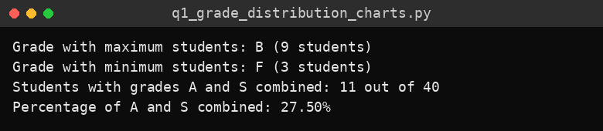
Console output
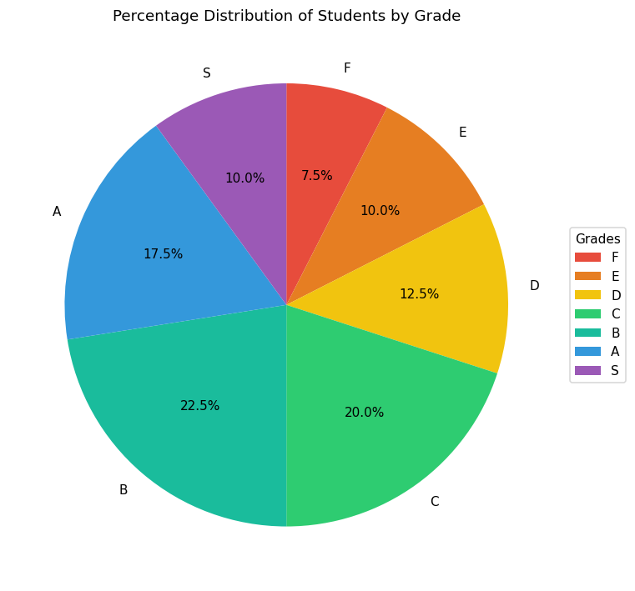
Figure 1: Pie chart – percentage distribution of students by grade
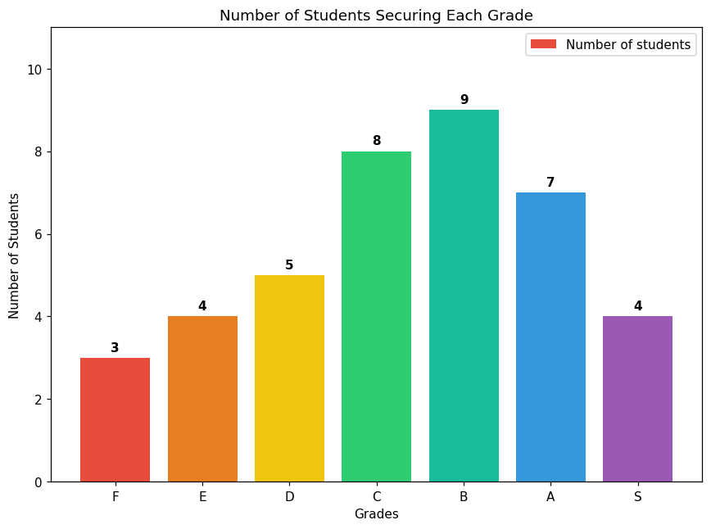
Figure 2: Bar chart – number of students securing each grade

Result
The pie chart and bar chart were drawn and saved successfully. Grade B has the maximum number of students (9), grade F has the minimum (3), and 11 out of 40 students (27.50%) secured grades A and S combined.

Question 2: Grade Analysis using a CSV File and pandas

Aim
To create a CSV file of grade-wise student counts, read and validate it with pandas, calculate percentages, generate pie and bar charts and save both charts as image files.

Algorithm
- Start and import os, sys, pandas and matplotlib.pyplot.
- Create student_grades.csv with the columns Grade and Number_of_Students if the file does not already exist.
- Read the CSV file into a DataFrame using pandas.
- Validate the data: all seven grades must be present, there must be no duplicates, the counts must be non-negative numbers and the total must be exactly 40; otherwise stop with an error message.
- Order the rows from F (lowest) to S (highest) and calculate the percentage for each grade.
- Display the grade-wise number and percentage of students.
- Find and display the grades with the highest and lowest number of students.
- Draw the pie chart with percentages, title and legend and save it as grade_pie_chart.png.
- Draw the bar chart with counts above the bars, axis labels, title and legend and save it as grade_bar_chart.png.
- Stop.

Code
"""
Q2: Read student grades from a CSV file using pandas, validate, analyse and plot.
Requires: pip install pandas matplotlib
"""
import os
import sys

import matplotlib.pyplot as plt
import pandas as pd

CSV_FILE = "student_grades.csv"
EXPECTED_GRADES = ["F", "E", "D", "C", "B", "A", "S"]
EXPECTED_TOTAL = 40

# 1 & 2. Create the CSV file (only if it does not already exist)
if not os.path.exists(CSV_FILE):
pd.DataFrame(
{
"Grade": EXPECTED_GRADES,
"Number_of_Students": [3, 4, 5, 8, 9, 7, 4],
}
).to_csv(CSV_FILE, index=False)
print(f"Created {CSV_FILE}")

# 3. Read the CSV file using pandas
df = pd.read_csv(CSV_FILE)

# 4. Validate the data
df["Grade"] = df["Grade"].astype(str).str.strip().str.upper()

missing = [g for g in EXPECTED_GRADES if g not in df["Grade"].values]
if missing:
sys.exit(f"Validation failed: missing grades {missing}")

if df["Grade"].duplicated().any():
sys.exit("Validation failed: duplicate grades found")

if not pd.api.types.is_numeric_dtype(df["Number_of_Students"]) or (df["Number_of_Students"] < 0).any():
sys.exit("Validation failed: Number_of_Students must be non-negative numbers")

total = int(df["Number_of_Students"].sum())
if total != EXPECTED_TOTAL:
sys.exit(f"Validation failed: total is {total}, expected {EXPECTED_TOTAL}")

print("Validation successful: all 7 grades present and total = 40\n")

# Order the rows from F (lowest) to S (highest)
df["Grade"] = pd.Categorical(df["Grade"], categories=EXPECTED_GRADES, ordered=True)
df = df.sort_values("Grade").reset_index(drop=True)

# 5. Calculate percentages
df["Percentage"] = (df["Number_of_Students"] / total * 100).round(2)

# 9. Display number and percentage for each grade
print("Grade-wise Summary")
print(df.to_string(index=False))

# 10. Highest and lowest
highest = df.loc[df["Number_of_Students"].idxmax()]
lowest = df.loc[df["Number_of_Students"].idxmin()]
print(f"\nHighest: Grade {highest['Grade']} with {int(highest['Number_of_Students'])} students")
print(f"Lowest : Grade {lowest['Grade']} with {int(lowest['Number_of_Students'])} students")

colors = ["#e74c3c", "#e67e22", "#f1c40f", "#2ecc71", "#1abc9c", "#3498db", "#9b59b6"]

# 6 & 8. Pie chart
plt.figure(figsize=(7, 7))
plt.pie(
df["Number_of_Students"],
labels=df["Grade"],
autopct="%1.1f%%",
colors=colors,
startangle=90,
counterclock=False,
)
plt.title("Percentage Distribution of Students by Grade")
plt.legend(df["Grade"], title="Grades", loc="center left", bbox_to_anchor=(1, 0.5))
plt.tight_layout()
plt.savefig("grade_pie_chart.png", dpi=150) # 11. Save as image
plt.show()

# 7 & 8. Bar chart
plt.figure(figsize=(8, 6))
bars = plt.bar(df["Grade"].astype(str), df["Number_of_Students"], color=colors, label="Number of students")
plt.xlabel("Grades")
plt.ylabel("Number of Students")
plt.title("Number of Students Securing Each Grade")
plt.ylim(0, df["Number_of_Students"].max() + 2)
for bar, count in zip(bars, df["Number_of_Students"]):
plt.text(bar.get_x() + bar.get_width() / 2, bar.get_height() + 0.1,
str(int(count)), ha="center", va="bottom", fontweight="bold")
plt.legend()
plt.tight_layout()
plt.savefig("grade_bar_chart.png", dpi=150) # 11. Save as image
plt.show()

print("\nCharts saved as grade_pie_chart.png and grade_bar_chart.png")

Output
Text output
Created student_grades.csv
Validation successful: all 7 grades present and total = 40

Grade-wise Summary
Grade Number_of_Students Percentage
F 3 7.5
E 4 10.0
D 5 12.5
C 8 20.0
B 9 22.5
A 7 17.5
S 4 10.0

Highest: Grade B with 9 students
Lowest : Grade F with 3 students

Charts saved as grade_pie_chart.png and grade_bar_chart.png

Generated file: student_grades.csv
Grade,Number_of_Students
F,3
E,4
D,5
C,8
B,9
A,7
S,4

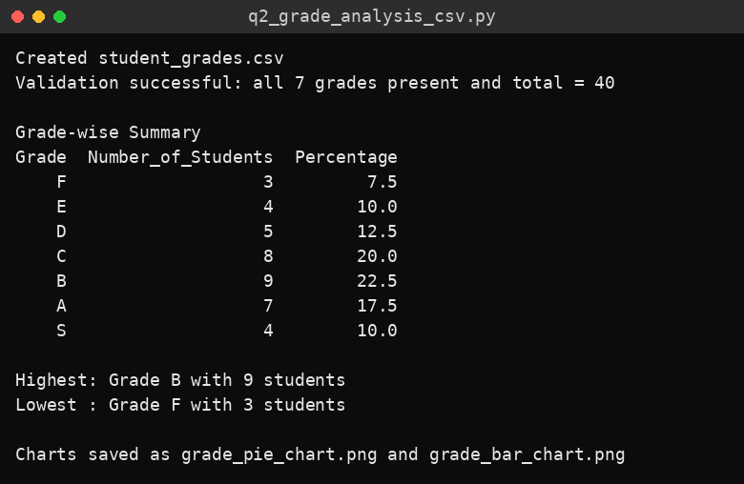
Console output
Figure 1: Pie chart saved as grade_pie_chart.png
Figure 2: Bar chart saved as grade_bar_chart.png

Result
The CSV file was created, read and validated successfully. The percentage of every grade was calculated, grade B had the highest count (9) and grade F the lowest (3), and both charts were generated and saved as image files.

Question 3: Knowledge-Driven Object Identification

Aim
To identify common classroom objects (laptop, book, chair, bottle, mobile phone and table) from an image using a pretrained MobileNetV3 classifier together with a knowledge base and IF–THEN rules that give the object’s category, properties, function and description.

Algorithm
- Start and import matplotlib, numpy and PIL.
- Build the knowledge base for the six objects with category, properties, function, description and the matching ImageNet labels.
- Accept a JPG, JPEG or PNG image path (single image, or a folder of test images); show an error for other file types or a missing file.
- Analyse the image: collect simple visual features (size, average colour, brightness) and obtain the top 10 predictions from the pretrained MobileNetV3 model using PyTorch.
- Rule R0: add the probabilities of all predicted labels that belong to the same knowledge-base object.
- Rule R1: if the best score is at least 0.30, the object is identified confidently.
- Rule R2: if the best score is between 0.10 and 0.30, report a possible match with a low-confidence warning.
- Rule R3: otherwise display that the object cannot be identified confidently.
- Retrieve and display the object name, confidence, category, properties, function and description, together with the derived IF–THEN facts (power source, portability, furniture).
- Display the input image with the result as its title.
- For folder testing, read the expected object from each file name, compare it with the prediction and display each result and the overall accuracy.
- Stop.

Code
"""
Q3: Knowledge-driven object identification (laptop, book, chair, bottle, mobile phone, table).

How it works
1. A pretrained image classifier (MobileNetV3 trained on ImageNet) analyses the image.
2. Its top predictions are matched against a hand-made KNOWLEDGE BASE.
3. IF-THEN rules decide the object, category, function and whether the system is confident.

Install:
pip install torch torchvision pillow matplotlib numpy
(the pretrained model is downloaded automatically the first time - internet needed once)

Run:
python q3_object_identification.py photo.jpg # single image
python q3_object_identification.py --folder test_images # test many images and get accuracy
(name test files like laptop_1.jpg, book_2.png, chair_3.jpeg ... so the
correct answer can be read from the file name)
"""
import os
import sys

import matplotlib.pyplot as plt
import numpy as np
from PIL import Image

ALLOWED_EXTENSIONS = (".jpg", ".jpeg", ".png")

# --------------------------------------------------------------------------
# KNOWLEDGE BASE
# "imagenet_labels" links the classifier's output labels to our objects.
# --------------------------------------------------------------------------
KNOWLEDGE_BASE = {
"laptop": {
"category": "Electronic device",
"properties": ["electronic", "portable", "has screen", "has keyboard"],
"function": "Used for computing, browsing, programming and online classes.",
"description": "A portable personal computer with a screen and keyboard in one folding unit.",
"imagenet_labels": ["laptop", "notebook"],
},
"book": {
"category": "Stationery / Learning material",
"properties": ["made of paper", "portable", "has pages", "non-electronic"],
"function": "Used for reading, studying and storing written knowledge.",
"description": "A set of printed pages bound together inside a cover.",
"imagenet_labels": ["book jacket", "comic book", "binder"],
},
"chair": {
"category": "Furniture",
"properties": ["has legs", "has seat", "has backrest", "non-electronic"],
"function": "Used for sitting.",
"description": "A piece of furniture with a seat, legs and usually a backrest for one person.",
"imagenet_labels": ["folding chair", "rocking chair", "barber chair", "throne", "park bench"],
},
"bottle": {
"category": "Container",
"properties": ["hollow", "has narrow neck", "holds liquid", "non-electronic"],
"function": "Used for storing and carrying liquids such as water.",
"description": "A container with a narrow neck and mouth, usually made of plastic or glass.",
"imagenet_labels": ["water bottle", "pop bottle", "beer bottle", "wine bottle",
"water jug", "pill bottle", "whiskey jug"],
},
"mobile phone": {
"category": "Electronic device",
"properties": ["electronic", "portable", "has touch screen", "wireless"],
"function": "Used for calling, messaging, internet access and photography.",
"description": "A handheld wireless device for communication and many other apps.",
"imagenet_labels": ["cellular telephone", "iPod", "hand-held computer"],
},
"table": {
"category": "Furniture",
"properties": ["has flat top", "has legs", "non-electronic"],
"function": "Used as a flat surface for writing, working, eating or keeping things.",
"description": "A piece of furniture with a flat top supported by legs.",
"imagenet_labels": ["desk", "dining table", "coffee table", "folding table"],
},
}

# Rule thresholds
HIGH_CONFIDENCE = 0.30 # R1: identified confidently
LOW_CONFIDENCE = 0.10 # R2: possible match, but not sure

# --------------------------------------------------------------------------
# IMAGE ANALYSIS
# --------------------------------------------------------------------------
_model_cache = {}

def classify_image(path, top_k=10):
"""Return a list of (imagenet_label, probability) using a pretrained CNN."""
import torch
from torchvision import models

if "model" not in _model_cache:
weights = models.MobileNet_V3_Large_Weights.DEFAULT
_model_cache["model"] = models.mobilenet_v3_large(weights=weights).eval()
_model_cache["transform"] = weights.transforms()
_model_cache["labels"] = weights.meta["categories"]

image = Image.open(path).convert("RGB")
batch = _model_cache["transform"](image).unsqueeze(0)
with torch.no_grad():
probs = torch.softmax(_model_cache["model"](batch)[0], dim=0)
values, indices = probs.topk(top_k)
return [(_model_cache["labels"][i], float(v)) for v, i in zip(values, indices)]

def basic_visual_features(path):
"""Simple visual information: size, average colour and brightness."""
img = Image.open(path).convert("RGB")
arr = np.asarray(img, dtype=float)
r, g, b = arr[..., 0].mean(), arr[..., 1].mean(), arr[..., 2].mean()
return {
"size": f"{img.width} x {img.height} px",
"average colour (R,G,B)": f"({r:.0f}, {g:.0f}, {b:.0f})",
"brightness": f"{arr.mean():.0f} / 255",
}

# --------------------------------------------------------------------------
# RULE-BASED REASONING
# --------------------------------------------------------------------------
def reason_over_predictions(predictions):
"""
R0: add up the probability of all classifier labels that belong to the same
knowledge-base object.
R1: IF best score >= 0.30 THEN object is identified confidently.
R2: IF 0.10 <= best score < 0.30 THEN object is only a possible match.
R3: ELSE the object cannot be identified.
Returns (object_name or None, score, status).
"""
scores = {name: 0.0 for name in KNOWLEDGE_BASE}
for label, prob in predictions:
for name, info in KNOWLEDGE_BASE.items():
if label.lower() in [l.lower() for l in info["imagenet_labels"]]:
scores[name] += prob

best = max(scores, key=scores.get)
best_score = scores[best]

if best_score >= HIGH_CONFIDENCE:
return best, best_score, "confident"
if best_score >= LOW_CONFIDENCE:
return best, best_score, "uncertain"
return None, best_score, "unknown"

def derived_facts(name):
"""Extra IF-THEN rules applied to the knowledge-base properties."""
info = KNOWLEDGE_BASE[name]
facts = []
if "electronic" in info["properties"]:
facts.append("RULE: electronic object -> needs a power source / battery")
else:
facts.append("RULE: non-electronic object -> needs no power source")
if info["category"] == "Furniture":
facts.append("RULE: furniture -> normally kept fixed in a classroom, not carried around")
if "portable" in info["properties"]:
facts.append("RULE: portable object -> can be carried in a bag")
return facts

# --------------------------------------------------------------------------
# DISPLAY
# --------------------------------------------------------------------------
def identify(path, show=True):
"""Run the whole pipeline on one image. Returns the identified object name or None."""
if not path.lower().endswith(ALLOWED_EXTENSIONS):
print("Error: only JPG, JPEG or PNG images are supported.")
return None
if not os.path.isfile(path):
print(f"Error: file '{path}' not found.")
return None

predictions = classify_image(path)
name, score, status = reason_over_predictions(predictions)

print("\n" + "=" * 55)
print("Image:", path)
print("Visual features:")
for k, v in basic_visual_features(path).items():
print(f" {k}: {v}")
print("Top classifier predictions:")
for label, p in predictions[:3]:
print(f" {label}: {p * 100:.1f}%")

if status == "unknown":
title = "Object cannot be identified confidently"
print("\nResult: the object could not be identified confidently.")
print("Please try a clearer, closer image of one object (laptop, book, chair, bottle, mobile phone or table).")
else:
info = KNOWLEDGE_BASE[name]
if status == "uncertain":
print(f"\nWarning: low confidence ({score * 100:.1f}%). This may be a {name}, but please verify.")
print(f"\nObject : {name.title()} (confidence {score * 100:.1f}%)")
print(f"Category : {info['category']}")
print(f"Properties : {', '.join(info['properties'])}")
print(f"Function : {info['function']}")
print(f"Description : {info['description']}")
for fact in derived_facts(name):
print(" ", fact)
title = f"{name.title()} ({score * 100:.0f}%)" + (" - low confidence" if status == "uncertain" else "")

if show:
plt.figure(figsize=(5, 5))
plt.imshow(Image.open(path).convert("RGB"))
plt.title(title)
plt.axis("off")
plt.show()

return name if status != "unknown" else None

# --------------------------------------------------------------------------
# TESTING / EVALUATION (task h)
# --------------------------------------------------------------------------
def evaluate_folder(folder):
files = sorted(f for f in os.listdir(folder) if f.lower().endswith(ALLOWED_EXTENSIONS))
if not files:
print("No JPG/PNG images found in", folder)
return
correct = 0
rows = []
for f in files:
expected = os.path.splitext(f)[0].split("_")[0].replace("-", " ").lower()
got = identify(os.path.join(folder, f), show=False)
ok = got == expected
correct += ok
rows.append((f, expected, got or "unidentified", "PASS" if ok else "FAIL"))

print("\n" + "=" * 55)
print(f"{'File':25}{'Expected':15}{'Predicted':15}{'Result'}")
for r in rows:
print(f"{r[0]:25}{r[1]:15}{r[2]:15}{r[3]}")
print(f"\nAccuracy: {correct}/{len(files)} = {correct / len(files) * 100:.1f}%")

def main():
args = sys.argv[1:]
if len(args) == 2 and args[0] == "--folder":
evaluate_folder(args[1])
elif len(args) == 1:
identify(args[0])
else:
while True:
path = input("\nEnter image path (or 'q' to quit): ").strip().strip('"')
if path.lower() == "q":
break
identify(path)

if __name__ == "__main__":
main()

Output
Run q3_object_identification.py with test images of a laptop, book, chair, bottle, mobile phone and table, and paste the screenshots of the input image and the IDLE output in the space below.
[ Paste output screenshots here ]

Test evaluation
S.No | Test image | Expected object | Identified object | Correct?
1
2
3
4
5
6

Result
The knowledge-driven system was implemented using a pretrained MobileNetV3 model for image analysis and a knowledge base with IF–THEN rules for category and function. (Add the results and accuracy from the test table above after running the program on your own images.)

Question 4: Number Plate Recognition using OCR and an Expert System (Complete Program)

Aim
To detect the number plate in a car image, extract the registration number with Tesseract OCR and validate it against the Indian registration format using a knowledge base and expert-system rules that allow for common OCR errors.

Algorithm
- Start and import re, sys, cv2, numpy, pytesseract and matplotlib.
- Build the knowledge base: registration pattern SS DD LLL NNNN, valid state/UT codes and OCR character-confusion tables.
- Read the image path from the command line or from the user; accept only JPG, JPEG or PNG files that can be read.
- Detect the plate with OpenCV’s pretrained Haar cascade; if it fails, use the contour-based fallback (four-sided contour with a plate-like aspect ratio). Crop the plate with a small padding.
- If no plate is found, display an error message.
- Preprocess the plate: enlarge, grayscale, bilateral-filter noise reduction, CLAHE contrast enhancement, Otsu and adaptive thresholding.
- Run Tesseract OCR (modes 7, 8 and 13, letters and digits only) on each preprocessed version to get candidate texts.
- Validate each candidate with the expert-system rules (see the validation rules below); stop at the first valid one.
- Display the original image with the detected plate marked, the cropped plate, the extracted number and the validation result; print the messages.
- If validation fails, ask the user to check another image; repeat until the user enters q.
- Stop.
- Rules used by the expert system: Rule 1 – text must not be empty; Rule 2 – length must be 9 to 11 characters; Rule 3 – text must match the pattern after OCR corrections; Rule 4 – the first two letters must be a valid state/UT code.

Code
"""
Q4: Number plate detection + OCR + knowledge-based validation (Indian format).

Install:
pip install opencv-python pytesseract matplotlib numpy
Also install the Tesseract OCR engine itself:
Windows : https://github.com/UB-Mannheim/tesseract/wiki (then set TESSERACT_PATH below)
Linux : sudo apt install tesseract-ocr
macOS : brew install tesseract

Run:
python q4_number_plate_recognition.py car.jpg
(or run without arguments and type the image path when asked)
"""
import re
import sys

import cv2
import matplotlib.pyplot as plt
import numpy as np
import pytesseract

# Windows users: uncomment and fix this path if Tesseract is not on PATH
# TESSERACT_PATH = r"C:\Program Files\Tesseract-OCR\tesseract.exe"
# pytesseract.pytesseract.tesseract_cmd = TESSERACT_PATH

# --------------------------------------------------------------------------
# KNOWLEDGE BASE (Indian vehicle registration format, e.g. TN09AB1234)
# --------------------------------------------------------------------------
KNOWLEDGE_BASE = {
"format_description": "SS DD LLL NNNN (State code, District number, Series letters, 4-digit number)",
"pattern": re.compile(r"^[A-Z]{2}[0-9]{2}[A-Z]{1,3}[0-9]{4}$"),
"state_codes": {
"AN", "AP", "AR", "AS", "BR", "CH", "CG", "DD", "DL", "DN", "GA", "GJ",
"HP", "HR", "JH", "JK", "KA", "KL", "LA", "LD", "MH", "ML", "MN", "MP",
"MZ", "NL", "OD", "OR", "PB", "PY", "RJ", "SK", "TN", "TR", "TS", "UK",
"UP", "WB",
},
# Characters OCR commonly confuses
"to_digit": {"O": "0", "Q": "0", "D": "0", "I": "1", "L": "1", "Z": "2",
"S": "5", "B": "8", "G": "6", "T": "7"},
"to_letter": {"0": "O", "1": "I", "2": "Z", "5": "S", "8": "B", "6": "G"},
}

# --------------------------------------------------------------------------
# 1. NUMBER PLATE DETECTION
# --------------------------------------------------------------------------
def detect_plate_haar(img):
"""Detect plate using OpenCV's pretrained Haar cascade."""
cascade_path = cv2.data.haarcascades + "haarcascade_russian_plate_number.xml"
cascade = cv2.CascadeClassifier(cascade_path)
gray = cv2.cvtColor(img, cv2.COLOR_BGR2GRAY)
plates = cascade.detectMultiScale(gray, scaleFactor=1.1, minNeighbors=4, minSize=(60, 20))
if len(plates) == 0:
return None
x, y, w, h = max(plates, key=lambda p: p[2] * p[3]) # largest detection
return x, y, w, h

def detect_plate_contour(img):
"""Fallback: look for a rectangular contour with a plate-like aspect ratio."""
gray = cv2.cvtColor(img, cv2.COLOR_BGR2GRAY)
gray = cv2.bilateralFilter(gray, 11, 17, 17)
edges = cv2.Canny(gray, 30, 200)
contours, _ = cv2.findContours(edges, cv2.RETR_TREE, cv2.CHAIN_APPROX_SIMPLE)
contours = sorted(contours, key=cv2.contourArea, reverse=True)[:30]

img_area = img.shape[0] * img.shape[1]
for c in contours:
peri = cv2.arcLength(c, True)
approx = cv2.approxPolyDP(c, 0.018 * peri, True)
if len(approx) == 4:
x, y, w, h = cv2.boundingRect(approx)
aspect = w / float(h)
area_ratio = (w * h) / img_area
if 2.0 <= aspect <= 6.5 and 0.005 <= area_ratio <= 0.5:
return x, y, w, h
return None

def detect_plate(img):
box = detect_plate_haar(img)
if box is None:
box = detect_plate_contour(img)
if box is None:
return None, None
x, y, w, h = box
pad = 4
x0, y0 = max(x - pad, 0), max(y - pad, 0)
x1, y1 = min(x + w + pad, img.shape[1]), min(y + h + pad, img.shape[0])
return img[y0:y1, x0:x1], (x0, y0, x1 - x0, y1 - y0)

# --------------------------------------------------------------------------
# 2. PREPROCESSING
# --------------------------------------------------------------------------
def preprocess_plate(plate):
"""Return a list of preprocessed versions of the plate for OCR."""
h, w = plate.shape[:2]
scale = max(1.0, 300.0 / h) # enlarge small plates
plate = cv2.resize(plate, None, fx=scale, fy=scale, interpolation=cv2.INTER_CUBIC)

gray = cv2.cvtColor(plate, cv2.COLOR_BGR2GRAY) # grayscale
blur = cv2.bilateralFilter(gray, 9, 75, 75) # noise reduction
clahe = cv2.createCLAHE(clipLimit=2.0, tileGridSize=(8, 8))
contrast = clahe.apply(blur) # contrast enhancement

_, otsu = cv2.threshold(contrast, 0, 255, cv2.THRESH_BINARY + cv2.THRESH_OTSU)
adaptive = cv2.adaptiveThreshold(contrast, 255, cv2.ADAPTIVE_THRESH_GAUSSIAN_C,
cv2.THRESH_BINARY, 31, 10)

# Add a white border so characters do not touch the image edge
otsu = cv2.copyMakeBorder(otsu, 15, 15, 15, 15, cv2.BORDER_CONSTANT, value=255)
adaptive = cv2.copyMakeBorder(adaptive, 15, 15, 15, 15, cv2.BORDER_CONSTANT, value=255)
return [otsu, adaptive, contrast]

# --------------------------------------------------------------------------
# 3. OCR
# --------------------------------------------------------------------------
def run_ocr(image):
"""Run Tesseract with a few page-segmentation modes; return cleaned candidates."""
whitelist = "ABCDEFGHIJKLMNOPQRSTUVWXYZ0123456789"
candidates = []
for psm in (7, 8, 13):
config = f"--oem 3 --psm {psm} -c tessedit_char_whitelist={whitelist}"
text = pytesseract.image_to_string(image, config=config)
cleaned = re.sub(r"[^A-Z0-9]", "", text.upper())
if cleaned:
candidates.append(cleaned)
return candidates

# --------------------------------------------------------------------------
# 4. EXPERT SYSTEM: RULE-BASED VALIDATION
# --------------------------------------------------------------------------
def apply_ocr_corrections(text):
"""
Rule: the plate layout is L L D D L(1-3) D D D D.
Using the position of each character, replace look-alike characters
(e.g. 'O' where a digit is expected -> '0').
"""
n = len(text)
if not 9 <= n <= 11:
return text, []
series_len = n - 8
layout = ["L", "L", "D", "D"] + ["L"] * series_len + ["D"] * 4

fixed, changes = [], []
for i, (ch, expected) in enumerate(zip(text, layout)):
new = ch
if expected == "D" and ch.isalpha():
new = KNOWLEDGE_BASE["to_digit"].get(ch, ch)
elif expected == "L" and ch.isdigit():
new = KNOWLEDGE_BASE["to_letter"].get(ch, ch)
if new != ch:
changes.append(f"position {i + 1}: '{ch}' -> '{new}'")
fixed.append(new)
return "".join(fixed), changes

def validate_plate(text):
"""Return (is_valid, final_text, messages)."""
messages = []
if not text:
return False, "", ["Rule 1 failed: no characters were read"]

if not 9 <= len(text) <= 11:
return False, text, [f"Rule 2 failed: length {len(text)} is not between 9 and 11"]

corrected, changes = apply_ocr_corrections(text)
if changes:
messages.append("OCR correction applied: " + "; ".join(changes))

if not KNOWLEDGE_BASE["pattern"].match(corrected):
messages.append("Rule 3 failed: text does not match format SS DD LLL NNNN")
return False, corrected, messages

if corrected[:2] not in KNOWLEDGE_BASE["state_codes"]:
messages.append(f"Rule 4 failed: '{corrected[:2]}' is not a valid state/UT code")
return False, corrected, messages

messages.append("All rules satisfied")
return True, corrected, messages

# --------------------------------------------------------------------------
# 5. MAIN PIPELINE
# --------------------------------------------------------------------------
def process_image(path):
if not path.lower().endswith((".jpg", ".jpeg", ".png")):
print("Error: only JPG, JPEG or PNG images are supported.")
return
img = cv2.imread(path)
if img is None:
print(f"Error: could not read image '{path}'. Check the file path.")
return

plate, box = detect_plate(img)
if plate is None:
print("Error: number plate could not be detected. Try a clearer, closer image.")
show_results(img, None, None, "NOT DETECTED", "Plate not found")
return

best_text, best_msgs, valid = "", [], False
first_candidate = ""
for version in preprocess_plate(plate):
for candidate in run_ocr(version):
if not first_candidate:
first_candidate = candidate
ok, final, msgs = validate_plate(candidate)
if ok:
best_text, best_msgs, valid = final, msgs, True
break
if valid:
break

if valid:
print(f"\nExtracted registration number : {best_text}")
print("Validation result : VALID")
for m in best_msgs:
print(" -", m)
show_results(img, box, plate, best_text, "VALID")
else:
print(f"\nOCR text (raw) : {first_candidate or '(nothing read)'}")
print("Validation result : INVALID / not confident")
_, _, msgs = validate_plate(first_candidate)
for m in msgs:
print(" -", m)
print("Please check the image and try again with a clearer picture.")
show_results(img, box, plate, first_candidate or "UNREADABLE", "INVALID")

def show_results(img, box, plate, text, status):
vis = img.copy()
if box is not None:
x, y, w, h = box
cv2.rectangle(vis, (x, y), (x + w, y + h), (0, 255, 0), 3)

fig, axes = plt.subplots(1, 2, figsize=(11, 4.5))
axes[0].imshow(cv2.cvtColor(vis, cv2.COLOR_BGR2RGB))
axes[0].set_title("Original image")
axes[0].axis("off")

if plate is not None:
axes[1].imshow(cv2.cvtColor(plate, cv2.COLOR_BGR2RGB))
else:
axes[1].imshow(np.ones((50, 200, 3), dtype=np.uint8) * 230)
axes[1].set_title(f"Cropped plate\nNumber: {text} Result: {status}")
axes[1].axis("off")
plt.tight_layout()
plt.show()

def main():
path = sys.argv[1] if len(sys.argv) > 1 else None
while True:
if path is None:
path = input("\nEnter car image path (or 'q' to quit): ").strip().strip('"')
if path.lower() == "q":
break
process_image(path)
path = None # ask again so the user can check another image

if __name__ == "__main__":
main()

Output
Text output
Enter car image path (or 'q' to quit): Q4_image.jpeg

OCR text (raw) : 1TN09BY9726
Validation result : INVALID / not confident
- OCR correction applied: position 1: '1' -> 'I'
- Rule 3 failed: text does not match format SS DD LLL NNNN
Please check the image and try again with a clearer picture.

Enter car image path (or 'q' to quit): q

Note: OCR results depend on the Tesseract version installed, so the text read on another computer may differ slightly.

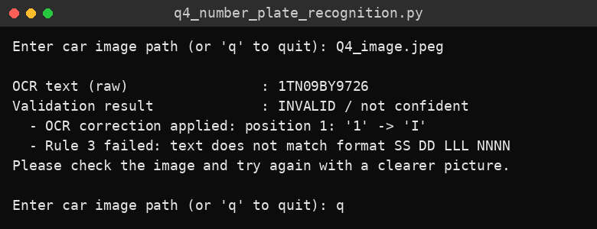
Console output
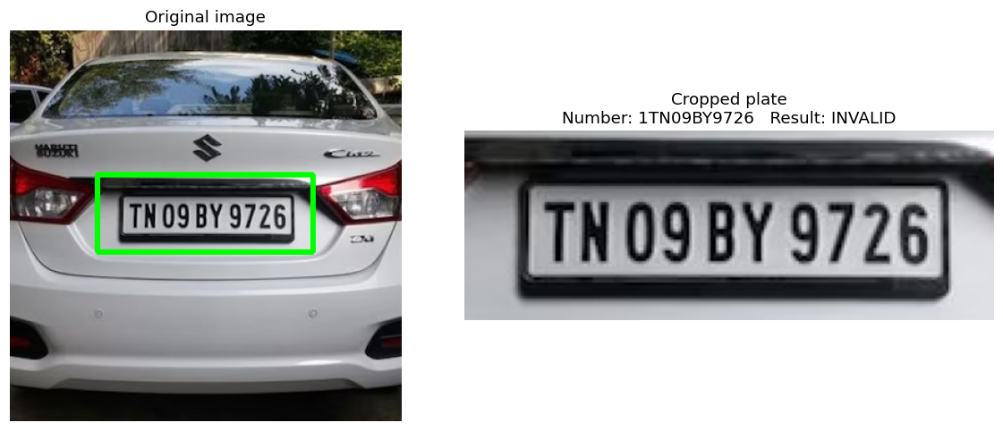
Figure 1: Detected plate (green box) and cropped plate with OCR result

Result
The plate was located with the Haar cascade and cropped correctly. OCR read the text as “1TN09BY9726”, with an extra leading character from the plate edge, so the expert-system rules rejected it (Rule 3) and the program asked for another image. This shows the validation and error-handling logic working; a cleaner crop or a different image gives a valid number.

Task 5: Input Image

Aim
To read a car image in JPG, JPEG or PNG format from a given file path and display it.

Algorithm
- Start and import cv2, matplotlib and the other required libraries.
- Read the image path from the command line or from the user.
- Check that the file extension is .jpg, .jpeg or .png; otherwise display an error.
- Read the image with cv2.imread(); if it cannot be read, display an error.
- Print the width and height of the loaded image.
- Convert the image from BGR to RGB and display it with matplotlib.
- Stop.

Code
"""
Step 5 - Input Image: read a car image (JPG/JPEG/PNG) and display it.
Install:
pip install opencv-python pytesseract matplotlib numpy
(and the Tesseract OCR program itself - see the Q4 notes)
Run: python step05_input_image.py car.jpg
"""
import re
import sys

import cv2
import matplotlib.pyplot as plt
import numpy as np
import pytesseract

# Windows users: uncomment and fix this path if Tesseract is not on PATH
# pytesseract.pytesseract.tesseract_cmd = r"C:\Program Files\Tesseract-OCR\tesseract.exe"

def load_image(path):
"""Step 5: read the image after checking its file type."""
if not path.lower().endswith((".jpg", ".jpeg", ".png")):
print("Error: only JPG, JPEG or PNG images are supported.")
return None
img = cv2.imread(path)
if img is None:
print(f"Error: could not read image '{path}'. Check the file path.")
return img

def main():
path = sys.argv[1] if len(sys.argv) > 1 else input("Enter car image path: ").strip().strip('"')
img = load_image(path)
if img is None:
return
print("Image loaded successfully. Size:", img.shape[1], "x", img.shape[0], "pixels")
plt.imshow(cv2.cvtColor(img, cv2.COLOR_BGR2RGB))
plt.title("Input car image")
plt.axis("off")
plt.show()

if __name__ == "__main__":
main()

Output
Text output
Image loaded successfully. Size: 360 x 360 pixels

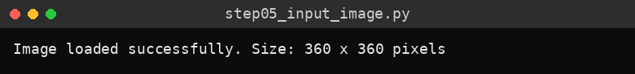
Console output
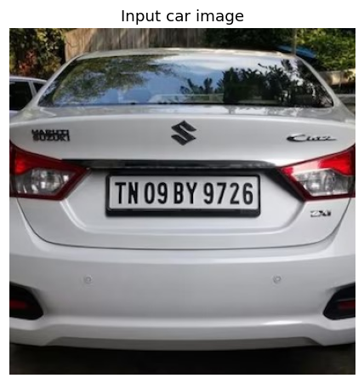
Figure 1: Input car image

Result
The car image was read and displayed successfully (360 × 360 pixels).

Task 6: Number Plate Detection

Aim
To locate and crop the number plate region in a car image using a pretrained Haar cascade with a contour-based fallback.

Algorithm
- Start and load the input image (Task 5).
- Convert the image to grayscale and run the Haar cascade for number plates; take the largest detection.
- If the cascade finds nothing, apply a bilateral filter and Canny edge detection, find contours and select a four-sided contour with a plate-like aspect ratio and size.
- Add a small padding and crop the plate region from the image.
- If no plate is found, display an error message.
- Print the plate position (x, y, width, height).
- Draw a green rectangle on the image and display it beside the cropped plate.
- Stop.

Code
"""
Step 6 - Number Plate Detection: locate and crop the plate.
Uses OpenCV's pretrained Haar cascade, with a contour-based fallback.
Install:
pip install opencv-python pytesseract matplotlib numpy
(and the Tesseract OCR program itself - see the Q4 notes)
Run: python step06_plate_detection.py car.jpg
"""
import re
import sys

import cv2
import matplotlib.pyplot as plt
import numpy as np
import pytesseract

# Windows users: uncomment and fix this path if Tesseract is not on PATH
# pytesseract.pytesseract.tesseract_cmd = r"C:\Program Files\Tesseract-OCR\tesseract.exe"

def load_image(path):
"""Step 5: read the image after checking its file type."""
if not path.lower().endswith((".jpg", ".jpeg", ".png")):
print("Error: only JPG, JPEG or PNG images are supported.")
return None
img = cv2.imread(path)
if img is None:
print(f"Error: could not read image '{path}'. Check the file path.")
return img

def detect_plate_haar(img):
"""Detect plate using OpenCV's pretrained Haar cascade."""
cascade_path = cv2.data.haarcascades + "haarcascade_russian_plate_number.xml"
cascade = cv2.CascadeClassifier(cascade_path)
gray = cv2.cvtColor(img, cv2.COLOR_BGR2GRAY)
plates = cascade.detectMultiScale(gray, scaleFactor=1.1, minNeighbors=4, minSize=(60, 20))
if len(plates) == 0:
return None
x, y, w, h = max(plates, key=lambda p: p[2] * p[3]) # largest detection
return x, y, w, h

def detect_plate_contour(img):
"""Fallback: look for a rectangular contour with a plate-like aspect ratio."""
gray = cv2.cvtColor(img, cv2.COLOR_BGR2GRAY)
gray = cv2.bilateralFilter(gray, 11, 17, 17)
edges = cv2.Canny(gray, 30, 200)
contours, _ = cv2.findContours(edges, cv2.RETR_TREE, cv2.CHAIN_APPROX_SIMPLE)
contours = sorted(contours, key=cv2.contourArea, reverse=True)[:30]

img_area = img.shape[0] * img.shape[1]
for c in contours:
peri = cv2.arcLength(c, True)
approx = cv2.approxPolyDP(c, 0.018 * peri, True)
if len(approx) == 4:
x, y, w, h = cv2.boundingRect(approx)
aspect = w / float(h)
area_ratio = (w * h) / img_area
if 2.0 <= aspect <= 6.5 and 0.005 <= area_ratio <= 0.5:
return x, y, w, h
return None

def detect_plate(img):
box = detect_plate_haar(img)
if box is None:
box = detect_plate_contour(img)
if box is None:
return None, None
x, y, w, h = box
pad = 4
x0, y0 = max(x - pad, 0), max(y - pad, 0)
x1, y1 = min(x + w + pad, img.shape[1]), min(y + h + pad, img.shape[0])
return img[y0:y1, x0:x1], (x0, y0, x1 - x0, y1 - y0)

def main():
path = sys.argv[1] if len(sys.argv) > 1 else input("Enter car image path: ").strip().strip('"')
img = load_image(path)
if img is None:
return
plate, box = detect_plate(img)
if plate is None:
print("Error: number plate could not be detected. Try a clearer, closer image.")
return
print("Plate found at (x, y, width, height):", tuple(int(v) for v in box))

marked = img.copy()
x, y, w, h = box
cv2.rectangle(marked, (x, y), (x + w, y + h), (0, 255, 0), 3)

fig, axes = plt.subplots(1, 2, figsize=(11, 4.5))
axes[0].imshow(cv2.cvtColor(marked, cv2.COLOR_BGR2RGB))
axes[0].set_title("Detected plate region")
axes[1].imshow(cv2.cvtColor(plate, cv2.COLOR_BGR2RGB))
axes[1].set_title("Cropped number plate")
for a in axes:
a.axis("off")
plt.tight_layout()
plt.show()

if __name__ == "__main__":
main()

Output
Text output
Plate found at (x, y, width, height): (80, 133, 198, 71)

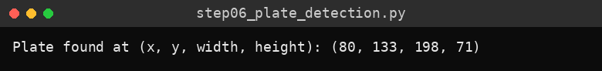
Console output
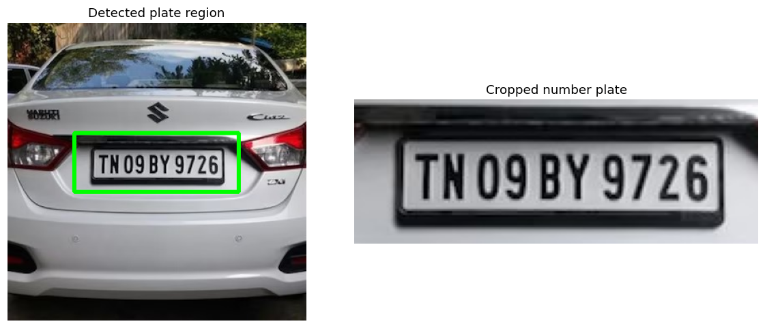
Figure 1: Detected plate region and cropped number plate

Result
The number plate was detected at (80, 133, 198, 71) and cropped successfully.

Task 7: Image Preprocessing

Aim
To preprocess the cropped plate (grayscale, noise reduction, contrast enhancement and thresholding) so that the characters become clear for OCR.

Algorithm
- Start, load the image and crop the plate (Tasks 5 and 6).
- Enlarge the plate so that its height is at least 300 pixels.
- Convert it to grayscale.
- Reduce noise with a bilateral filter.
- Improve the contrast with CLAHE.
- Apply Otsu thresholding and adaptive Gaussian thresholding, and add a white border to each result.
- Display all stages (cropped plate, grayscale, noise reduced and contrast enhanced, Otsu threshold, adaptive threshold) in one figure.
- Stop.

Code
"""
Step 7 - Image Preprocessing: grayscale, noise reduction, contrast
improvement (CLAHE) and thresholding to make the characters clear.
Install:
pip install opencv-python pytesseract matplotlib numpy
(and the Tesseract OCR program itself - see the Q4 notes)
Run: python step07_preprocessing.py car.jpg
"""
import re
import sys

import cv2
import matplotlib.pyplot as plt
import numpy as np
import pytesseract

# Windows users: uncomment and fix this path if Tesseract is not on PATH
# pytesseract.pytesseract.tesseract_cmd = r"C:\Program Files\Tesseract-OCR\tesseract.exe"

def load_image(path):
"""Step 5: read the image after checking its file type."""
if not path.lower().endswith((".jpg", ".jpeg", ".png")):
print("Error: only JPG, JPEG or PNG images are supported.")
return None
img = cv2.imread(path)
if img is None:
print(f"Error: could not read image '{path}'. Check the file path.")
return img

def detect_plate_haar(img):
"""Detect plate using OpenCV's pretrained Haar cascade."""
cascade_path = cv2.data.haarcascades + "haarcascade_russian_plate_number.xml"
cascade = cv2.CascadeClassifier(cascade_path)
gray = cv2.cvtColor(img, cv2.COLOR_BGR2GRAY)
plates = cascade.detectMultiScale(gray, scaleFactor=1.1, minNeighbors=4, minSize=(60, 20))
if len(plates) == 0:
return None
x, y, w, h = max(plates, key=lambda p: p[2] * p[3]) # largest detection
return x, y, w, h

def detect_plate_contour(img):
"""Fallback: look for a rectangular contour with a plate-like aspect ratio."""
gray = cv2.cvtColor(img, cv2.COLOR_BGR2GRAY)
gray = cv2.bilateralFilter(gray, 11, 17, 17)
edges = cv2.Canny(gray, 30, 200)
contours, _ = cv2.findContours(edges, cv2.RETR_TREE, cv2.CHAIN_APPROX_SIMPLE)
contours = sorted(contours, key=cv2.contourArea, reverse=True)[:30]

img_area = img.shape[0] * img.shape[1]
for c in contours:
peri = cv2.arcLength(c, True)
approx = cv2.approxPolyDP(c, 0.018 * peri, True)
if len(approx) == 4:
x, y, w, h = cv2.boundingRect(approx)
aspect = w / float(h)
area_ratio = (w * h) / img_area
if 2.0 <= aspect <= 6.5 and 0.005 <= area_ratio <= 0.5:
return x, y, w, h
return None

def detect_plate(img):
box = detect_plate_haar(img)
if box is None:
box = detect_plate_contour(img)
if box is None:
return None, None
x, y, w, h = box
pad = 4
x0, y0 = max(x - pad, 0), max(y - pad, 0)
x1, y1 = min(x + w + pad, img.shape[1]), min(y + h + pad, img.shape[0])
return img[y0:y1, x0:x1], (x0, y0, x1 - x0, y1 - y0)

def preprocess_plate(plate):
"""Return a list of preprocessed versions of the plate for OCR."""
h, w = plate.shape[:2]
scale = max(1.0, 300.0 / h) # enlarge small plates
plate = cv2.resize(plate, None, fx=scale, fy=scale, interpolation=cv2.INTER_CUBIC)

gray = cv2.cvtColor(plate, cv2.COLOR_BGR2GRAY) # grayscale
blur = cv2.bilateralFilter(gray, 9, 75, 75) # noise reduction
clahe = cv2.createCLAHE(clipLimit=2.0, tileGridSize=(8, 8))
contrast = clahe.apply(blur) # contrast enhancement

_, otsu = cv2.threshold(contrast, 0, 255, cv2.THRESH_BINARY + cv2.THRESH_OTSU)
adaptive = cv2.adaptiveThreshold(contrast, 255, cv2.ADAPTIVE_THRESH_GAUSSIAN_C,
cv2.THRESH_BINARY, 31, 10)

# Add a white border so characters do not touch the image edge
otsu = cv2.copyMakeBorder(otsu, 15, 15, 15, 15, cv2.BORDER_CONSTANT, value=255)
adaptive = cv2.copyMakeBorder(adaptive, 15, 15, 15, 15, cv2.BORDER_CONSTANT, value=255)
return [otsu, adaptive, contrast]

def main():
path = sys.argv[1] if len(sys.argv) > 1 else input("Enter car image path: ").strip().strip('"')
img = load_image(path)
if img is None:
return
plate, _ = detect_plate(img)
if plate is None:
print("Error: number plate could not be detected.")
return

gray = cv2.cvtColor(plate, cv2.COLOR_BGR2GRAY)
otsu, adaptive, contrast = preprocess_plate(plate)

stages = [
("Cropped plate", cv2.cvtColor(plate, cv2.COLOR_BGR2RGB)),
("Grayscale", gray),
("Noise reduced + contrast (CLAHE)", contrast),
("Otsu threshold", otsu),
("Adaptive threshold", adaptive),
]
plt.figure(figsize=(12, 7))
for i, (title, image) in enumerate(stages, 1):
plt.subplot(3, 2, i)
plt.imshow(image, cmap=None if image.ndim == 3 else "gray")
plt.title(title)
plt.axis("off")
plt.tight_layout()
plt.show()

if __name__ == "__main__":
main()

Output
This program shows only a figure and prints no text on the console.

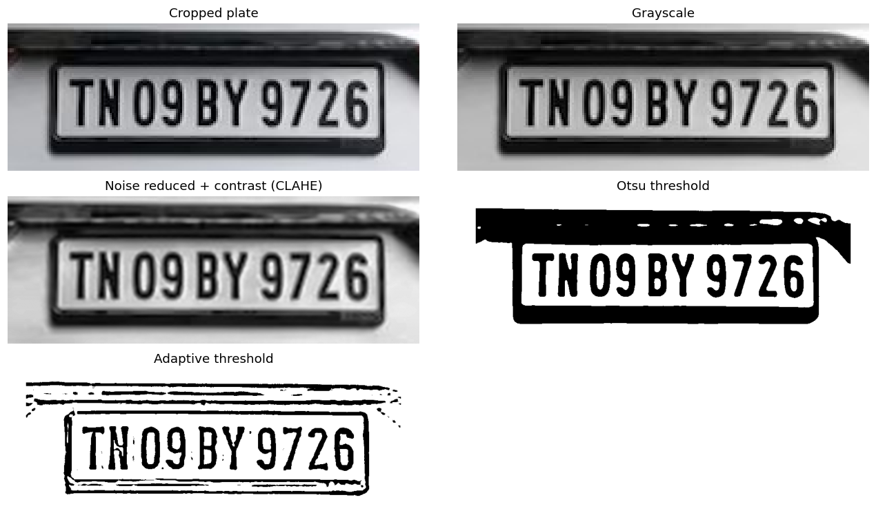
Figure 1: Stages of plate preprocessing

Result
The cropped plate was converted through grayscale, noise reduction, contrast enhancement and two thresholding methods, and the characters became clearly visible for OCR.

Task 8: Text Extraction using Tesseract OCR

Aim
To extract the registration characters from the preprocessed number plate using Tesseract OCR.

Algorithm
- Start, load the image, detect and crop the plate and preprocess it (Tasks 5 to 7).
- For each preprocessed version, run Tesseract with page-segmentation modes 7, 8 and 13, allowing only upper-case letters and digits.
- Remove all other characters from the OCR output and keep the non-empty results as candidates.
- Print the candidates obtained for the Otsu, adaptive and contrast-enhanced versions.
- Display a note that raw OCR text may contain mistakes and is validated in Task 10.
- Stop.

Code
"""
Step 8 - Text Extraction: use Tesseract OCR to read the characters.
Install:
pip install opencv-python pytesseract matplotlib numpy
(and the Tesseract OCR program itself - see the Q4 notes)
Run: python step08_text_extraction.py car.jpg
"""
import re
import sys

import cv2
import matplotlib.pyplot as plt
import numpy as np
import pytesseract

# Windows users: uncomment and fix this path if Tesseract is not on PATH
# pytesseract.pytesseract.tesseract_cmd = r"C:\Program Files\Tesseract-OCR\tesseract.exe"

def load_image(path):
"""Step 5: read the image after checking its file type."""
if not path.lower().endswith((".jpg", ".jpeg", ".png")):
print("Error: only JPG, JPEG or PNG images are supported.")
return None
img = cv2.imread(path)
if img is None:
print(f"Error: could not read image '{path}'. Check the file path.")
return img

def detect_plate_haar(img):
"""Detect plate using OpenCV's pretrained Haar cascade."""
cascade_path = cv2.data.haarcascades + "haarcascade_russian_plate_number.xml"
cascade = cv2.CascadeClassifier(cascade_path)
gray = cv2.cvtColor(img, cv2.COLOR_BGR2GRAY)
plates = cascade.detectMultiScale(gray, scaleFactor=1.1, minNeighbors=4, minSize=(60, 20))
if len(plates) == 0:
return None
x, y, w, h = max(plates, key=lambda p: p[2] * p[3]) # largest detection
return x, y, w, h

def detect_plate_contour(img):
"""Fallback: look for a rectangular contour with a plate-like aspect ratio."""
gray = cv2.cvtColor(img, cv2.COLOR_BGR2GRAY)
gray = cv2.bilateralFilter(gray, 11, 17, 17)
edges = cv2.Canny(gray, 30, 200)
contours, _ = cv2.findContours(edges, cv2.RETR_TREE, cv2.CHAIN_APPROX_SIMPLE)
contours = sorted(contours, key=cv2.contourArea, reverse=True)[:30]

img_area = img.shape[0] * img.shape[1]
for c in contours:
peri = cv2.arcLength(c, True)
approx = cv2.approxPolyDP(c, 0.018 * peri, True)
if len(approx) == 4:
x, y, w, h = cv2.boundingRect(approx)
aspect = w / float(h)
area_ratio = (w * h) / img_area
if 2.0 <= aspect <= 6.5 and 0.005 <= area_ratio <= 0.5:
return x, y, w, h
return None

def detect_plate(img):
box = detect_plate_haar(img)
if box is None:
box = detect_plate_contour(img)
if box is None:
return None, None
x, y, w, h = box
pad = 4
x0, y0 = max(x - pad, 0), max(y - pad, 0)
x1, y1 = min(x + w + pad, img.shape[1]), min(y + h + pad, img.shape[0])
return img[y0:y1, x0:x1], (x0, y0, x1 - x0, y1 - y0)

def preprocess_plate(plate):
"""Return a list of preprocessed versions of the plate for OCR."""
h, w = plate.shape[:2]
scale = max(1.0, 300.0 / h) # enlarge small plates
plate = cv2.resize(plate, None, fx=scale, fy=scale, interpolation=cv2.INTER_CUBIC)

gray = cv2.cvtColor(plate, cv2.COLOR_BGR2GRAY) # grayscale
blur = cv2.bilateralFilter(gray, 9, 75, 75) # noise reduction
clahe = cv2.createCLAHE(clipLimit=2.0, tileGridSize=(8, 8))
contrast = clahe.apply(blur) # contrast enhancement

_, otsu = cv2.threshold(contrast, 0, 255, cv2.THRESH_BINARY + cv2.THRESH_OTSU)
adaptive = cv2.adaptiveThreshold(contrast, 255, cv2.ADAPTIVE_THRESH_GAUSSIAN_C,
cv2.THRESH_BINARY, 31, 10)

# Add a white border so characters do not touch the image edge
otsu = cv2.copyMakeBorder(otsu, 15, 15, 15, 15, cv2.BORDER_CONSTANT, value=255)
adaptive = cv2.copyMakeBorder(adaptive, 15, 15, 15, 15, cv2.BORDER_CONSTANT, value=255)
return [otsu, adaptive, contrast]

def run_ocr(image):
"""Run Tesseract with a few page-segmentation modes; return cleaned candidates."""
whitelist = "ABCDEFGHIJKLMNOPQRSTUVWXYZ0123456789"
candidates = []
for psm in (7, 8, 13):
config = f"--oem 3 --psm {psm} -c tessedit_char_whitelist={whitelist}"
text = pytesseract.image_to_string(image, config=config)
cleaned = re.sub(r"[^A-Z0-9]", "", text.upper())
if cleaned:
candidates.append(cleaned)
return candidates

def main():
path = sys.argv[1] if len(sys.argv) > 1 else input("Enter car image path: ").strip().strip('"')
img = load_image(path)
if img is None:
return
plate, _ = detect_plate(img)
if plate is None:
print("Error: number plate could not be detected.")
return

names = ["Otsu threshold", "Adaptive threshold", "Contrast enhanced"]
for name, version in zip(names, preprocess_plate(plate)):
print(f"OCR on {name}: {run_ocr(version) or '(nothing read)'}")
print("\nNote: raw OCR text can contain mistakes. Step 10 validates it.")

if __name__ == "__main__":
main()

Output
Text output
OCR on Otsu threshold: ['1TN09BY9726', 'T2', 'T2']
OCR on Adaptive threshold: ['T725', 'T725']
OCR on Contrast enhanced: ['TTHOBY97261', 'T72', 'T72']

Note: raw OCR text can contain mistakes. Step 10 validates it.

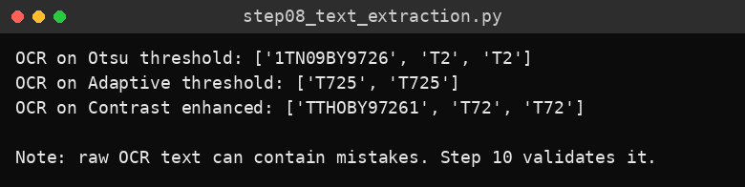
Console output

Result
Tesseract extracted candidate texts from the three preprocessed versions. The Otsu version gave “1TN09BY9726”, which contains the correct plate characters plus an extra leading character, showing why the validation step is needed.

Task 9: Knowledge Base Construction

Aim
To build a knowledge base containing the Indian vehicle registration format, expected character patterns, state codes, OCR confusions and validation rules.

Algorithm
- Start and import re.
- Create the knowledge base dictionary with the format description, the regular-expression pattern ^[A-Z]{2}[0-9]{2}[A-Z]{1,3}[0-9]{4}$, the set of state/UT codes, and the letter-to-digit and digit-to-letter OCR confusion tables.
- Print the format and an example registration number.
- Print the regular-expression pattern and the number and list of state codes.
- Print the position-wise character pattern (2 letters, 2 digits, 1–3 letters, 4 digits).
- Print the common OCR confusions.
- Print the four validation rules.
- Stop.

Code
"""
Step 9 - Knowledge Base Construction: registration format, character
patterns and validation rules for Indian number plates.
Run: python step09_knowledge_base.py (no image needed)
"""
import re

KNOWLEDGE_BASE = {
"format_description": "SS DD LLL NNNN (State code, District number, Series letters, 4-digit number)",
"pattern": re.compile(r"^[A-Z]{2}[0-9]{2}[A-Z]{1,3}[0-9]{4}$"),
"state_codes": {
"AN", "AP", "AR", "AS", "BR", "CH", "CG", "DD", "DL", "DN", "GA", "GJ",
"HP", "HR", "JH", "JK", "KA", "KL", "LA", "LD", "MH", "ML", "MN", "MP",
"MZ", "NL", "OD", "OR", "PB", "PY", "RJ", "SK", "TN", "TR", "TS", "UK",
"UP", "WB",
},
# Characters OCR commonly confuses
"to_digit": {"O": "0", "Q": "0", "D": "0", "I": "1", "L": "1", "Z": "2",
"S": "5", "B": "8", "G": "6", "T": "7"},
"to_letter": {"0": "O", "1": "I", "2": "Z", "5": "S", "8": "B", "6": "G"},
}

def main():
kb = KNOWLEDGE_BASE
print("KNOWLEDGE BASE - Indian vehicle registration number")
print("Format :", kb["format_description"])
print("Example : TN09AB1234 (TN = Tamil Nadu, 09 = district, AB = series, 1234 = number)")
print("Regex pattern :", kb["pattern"].pattern)
print(f"State codes : {len(kb['state_codes'])} -> {', '.join(sorted(kb['state_codes']))}")
print("\nCharacter patterns (position-wise):")
print(" Positions 1-2 : letters (state/UT code)")
print(" Positions 3-4 : digits (district number)")
print(" Next 1-3 chars : letters (series)")
print(" Last 4 chars : digits (vehicle number)")
print("\nCommon OCR confusions:")
print(" Letter read where a digit is expected :", kb["to_digit"])
print(" Digit read where a letter is expected :", kb["to_letter"])
print("\nValidation rules:")
print(" Rule 1: text must not be empty")
print(" Rule 2: length must be 9 to 11 characters")
print(" Rule 3: text must match the pattern after OCR corrections")
print(" Rule 4: first two letters must be a valid state/UT code")

if __name__ == "__main__":
main()

Output
Text output
KNOWLEDGE BASE - Indian vehicle registration number
Format : SS DD LLL NNNN (State code, District number, Series letters, 4-digit number)
Example : TN09AB1234 (TN = Tamil Nadu, 09 = district, AB = series, 1234 = number)
Regex pattern : ^[A-Z]{2}[0-9]{2}[A-Z]{1,3}[0-9]{4}$
State codes : 38 -> AN, AP, AR, AS, BR, CG, CH, DD, DL, DN, GA, GJ, HP, HR, JH, JK, KA, KL, LA, LD, MH, ML, MN, MP, MZ, NL, OD, OR, PB, PY, RJ, SK, TN, TR, TS, UK, UP, WB

Character patterns (position-wise):
Positions 1-2 : letters (state/UT code)
Positions 3-4 : digits (district number)
Next 1-3 chars : letters (series)
Last 4 chars : digits (vehicle number)

Common OCR confusions:
Letter read where a digit is expected : {'O': '0', 'Q': '0', 'D': '0', 'I': '1', 'L': '1', 'Z': '2', 'S': '5', 'B': '8', 'G': '6', 'T': '7'}
Digit read where a letter is expected : {'0': 'O', '1': 'I', '2': 'Z', '5': 'S', '8': 'B', '6': 'G'}

Validation rules:
Rule 1: text must not be empty
Rule 2: length must be 9 to 11 characters
Rule 3: text must match the pattern after OCR corrections
Rule 4: first two letters must be a valid state/UT code

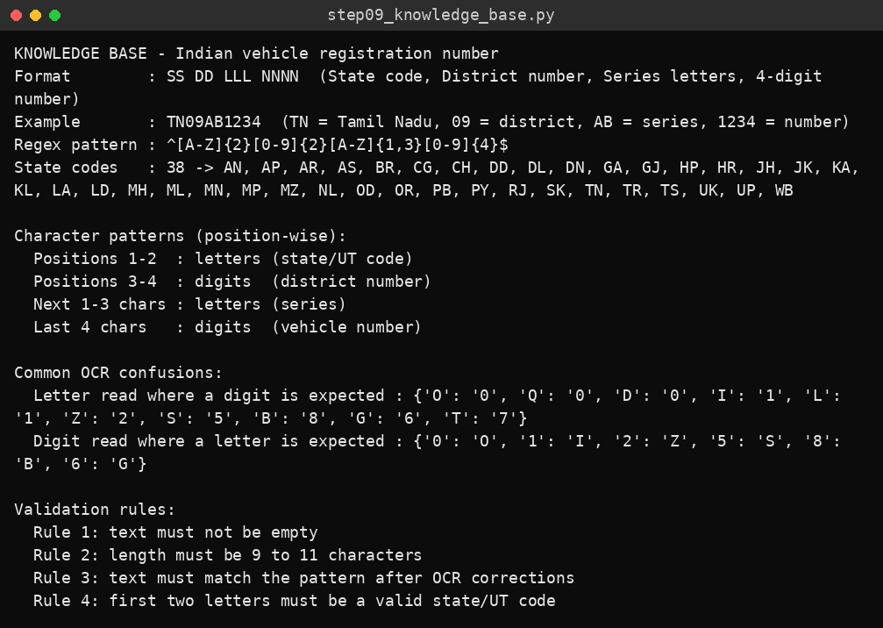
Console output

Result
The knowledge base for Indian registration numbers was constructed and displayed, with the format, 38 state/UT codes, OCR confusion tables and four validation rules.

Task 10: Rule-Based Validation

Aim
To validate OCR text against the registration format using expert-system rules that also correct common OCR errors.

Algorithm
- Start and load the knowledge base.
- Define apply_ocr_corrections(): for a text of 9 to 11 characters, build the layout L L D D L(1–3) D D D D and replace look-alike characters by position (for example “O” where a digit is expected becomes “0”).
- Define validate_plate(): Rule 1 – the text is not empty; Rule 2 – the length is 9 to 11; apply the OCR corrections; Rule 3 – the text matches the pattern; Rule 4 – the first two letters are a valid state/UT code.
- Test the rules on six sample OCR texts and print the final text, the result and the messages.
- Let the user enter their own OCR text, clean it and validate it, until the user enters q.
- Stop.

Code
"""
Step 10 - Rule-Based Validation: expert-system rules check the OCR text
against the registration format, allowing for common OCR errors.
Run: python step10_rule_based_validation.py (no image needed)
"""
import re

KNOWLEDGE_BASE = {
"format_description": "SS DD LLL NNNN (State code, District number, Series letters, 4-digit number)",
"pattern": re.compile(r"^[A-Z]{2}[0-9]{2}[A-Z]{1,3}[0-9]{4}$"),
"state_codes": {
"AN", "AP", "AR", "AS", "BR", "CH", "CG", "DD", "DL", "DN", "GA", "GJ",
"HP", "HR", "JH", "JK", "KA", "KL", "LA", "LD", "MH", "ML", "MN", "MP",
"MZ", "NL", "OD", "OR", "PB", "PY", "RJ", "SK", "TN", "TR", "TS", "UK",
"UP", "WB",
},
# Characters OCR commonly confuses
"to_digit": {"O": "0", "Q": "0", "D": "0", "I": "1", "L": "1", "Z": "2",
"S": "5", "B": "8", "G": "6", "T": "7"},
"to_letter": {"0": "O", "1": "I", "2": "Z", "5": "S", "8": "B", "6": "G"},
}

def apply_ocr_corrections(text):
"""
Rule: the plate layout is L L D D L(1-3) D D D D.
Using the position of each character, replace look-alike characters
(e.g. 'O' where a digit is expected -> '0').
"""
n = len(text)
if not 9 <= n <= 11:
return text, []
series_len = n - 8
layout = ["L", "L", "D", "D"] + ["L"] * series_len + ["D"] * 4

fixed, changes = [], []
for i, (ch, expected) in enumerate(zip(text, layout)):
new = ch
if expected == "D" and ch.isalpha():
new = KNOWLEDGE_BASE["to_digit"].get(ch, ch)
elif expected == "L" and ch.isdigit():
new = KNOWLEDGE_BASE["to_letter"].get(ch, ch)
if new != ch:
changes.append(f"position {i + 1}: '{ch}' -> '{new}'")
fixed.append(new)
return "".join(fixed), changes

def validate_plate(text):
"""Return (is_valid, final_text, messages)."""
messages = []
if not text:
return False, "", ["Rule 1 failed: no characters were read"]

if not 9 <= len(text) <= 11:
return False, text, [f"Rule 2 failed: length {len(text)} is not between 9 and 11"]

corrected, changes = apply_ocr_corrections(text)
if changes:
messages.append("OCR correction applied: " + "; ".join(changes))

if not KNOWLEDGE_BASE["pattern"].match(corrected):
messages.append("Rule 3 failed: text does not match format SS DD LLL NNNN")
return False, corrected, messages

if corrected[:2] not in KNOWLEDGE_BASE["state_codes"]:
messages.append(f"Rule 4 failed: '{corrected[:2]}' is not a valid state/UT code")
return False, corrected, messages

messages.append("All rules satisfied")
return True, corrected, messages

def show(text):
ok, final, messages = validate_plate(text)
print(f"\nInput text : {text or '(empty)'}")
print(f"Final text : {final}")
print("Result :", "VALID" if ok else "INVALID")
for m in messages:
print(" -", m)

def main():
samples = [
"TN09AB1234", # correct
"TNO9AB1234", # O read instead of 0 -> corrected
"TN09A81234", # 8 read instead of B -> corrected
"XX09AB1234", # invalid state code
"TN09AB12", # too short
"", # nothing read
]
print("Testing sample OCR outputs")
for s in samples:
show(s)

print("\n--- Try your own ---")
while True:
text = input("\nEnter OCR text to validate (or 'q' to quit): ").strip().upper()
if text == "Q":
break
show(re.sub(r"[^A-Z0-9]", "", text))

if __name__ == "__main__":
main()

Output
Text output
Testing sample OCR outputs

Input text : TN09AB1234
Final text : TN09AB1234
Result : VALID
- All rules satisfied

Input text : TNO9AB1234
Final text : TN09AB1234
Result : VALID
- OCR correction applied: position 3: 'O' -> '0'
- All rules satisfied

Input text : TN09A81234
Final text : TN09AB1234
Result : VALID
- OCR correction applied: position 6: '8' -> 'B'
- All rules satisfied

Input text : XX09AB1234
Final text : XX09AB1234
Result : INVALID
- Rule 4 failed: 'XX' is not a valid state/UT code

Input text : TN09AB12
Final text : TN09AB12
Result : INVALID
- Rule 2 failed: length 8 is not between 9 and 11

Input text : (empty)
Final text :
Result : INVALID
- Rule 1 failed: no characters were read

--- Try your own ---

Enter OCR text to validate (or 'q' to quit): tn09ab1234

Input text : TN09AB1234
Final text : TN09AB1234
Result : VALID
- All rules satisfied

Enter OCR text to validate (or 'q' to quit): q

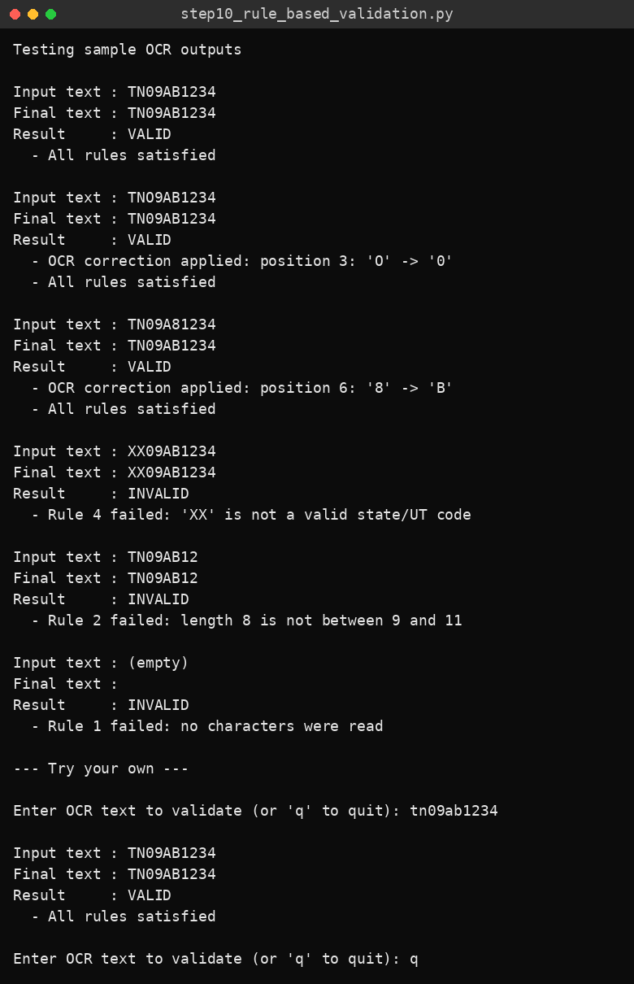
Console output

Result
The rules accepted the correct number and the two numbers with OCR errors (after correcting “O” to “0” and “8” to “B”), and correctly rejected the invalid state code, the text that was too short and the empty text.

Task 11: Result Display

Aim
To display the original image, the cropped number plate, the extracted registration number and the validation result.

Algorithm
- Start, load the image and detect and crop the plate.
- Preprocess the plate and run OCR on each version.
- Validate each candidate with the expert-system rules; stop at the first valid one, otherwise keep the first candidate read.
- Print the extracted registration number and the validation result.
- Display the original image with the plate marked and the cropped plate, with the number and result in the title.
- Stop.

Code
"""
Step 11 - Result Display: show the original image, cropped plate,
extracted registration number and validation result.
Install:
pip install opencv-python pytesseract matplotlib numpy
(and the Tesseract OCR program itself - see the Q4 notes)
Run: python step11_result_display.py car.jpg
"""
import re
import sys

import cv2
import matplotlib.pyplot as plt
import numpy as np
import pytesseract

# Windows users: uncomment and fix this path if Tesseract is not on PATH
# pytesseract.pytesseract.tesseract_cmd = r"C:\Program Files\Tesseract-OCR\tesseract.exe"

def load_image(path):
"""Step 5: read the image after checking its file type."""
if not path.lower().endswith((".jpg", ".jpeg", ".png")):
print("Error: only JPG, JPEG or PNG images are supported.")
return None
img = cv2.imread(path)
if img is None:
print(f"Error: could not read image '{path}'. Check the file path.")
return img

KNOWLEDGE_BASE = {
"format_description": "SS DD LLL NNNN (State code, District number, Series letters, 4-digit number)",
"pattern": re.compile(r"^[A-Z]{2}[0-9]{2}[A-Z]{1,3}[0-9]{4}$"),
"state_codes": {
"AN", "AP", "AR", "AS", "BR", "CH", "CG", "DD", "DL", "DN", "GA", "GJ",
"HP", "HR", "JH", "JK", "KA", "KL", "LA", "LD", "MH", "ML", "MN", "MP",
"MZ", "NL", "OD", "OR", "PB", "PY", "RJ", "SK", "TN", "TR", "TS", "UK",
"UP", "WB",
},
# Characters OCR commonly confuses
"to_digit": {"O": "0", "Q": "0", "D": "0", "I": "1", "L": "1", "Z": "2",
"S": "5", "B": "8", "G": "6", "T": "7"},
"to_letter": {"0": "O", "1": "I", "2": "Z", "5": "S", "8": "B", "6": "G"},
}

def detect_plate_haar(img):
"""Detect plate using OpenCV's pretrained Haar cascade."""
cascade_path = cv2.data.haarcascades + "haarcascade_russian_plate_number.xml"
cascade = cv2.CascadeClassifier(cascade_path)
gray = cv2.cvtColor(img, cv2.COLOR_BGR2GRAY)
plates = cascade.detectMultiScale(gray, scaleFactor=1.1, minNeighbors=4, minSize=(60, 20))
if len(plates) == 0:
return None
x, y, w, h = max(plates, key=lambda p: p[2] * p[3]) # largest detection
return x, y, w, h

def detect_plate_contour(img):
"""Fallback: look for a rectangular contour with a plate-like aspect ratio."""
gray = cv2.cvtColor(img, cv2.COLOR_BGR2GRAY)
gray = cv2.bilateralFilter(gray, 11, 17, 17)
edges = cv2.Canny(gray, 30, 200)
contours, _ = cv2.findContours(edges, cv2.RETR_TREE, cv2.CHAIN_APPROX_SIMPLE)
contours = sorted(contours, key=cv2.contourArea, reverse=True)[:30]

img_area = img.shape[0] * img.shape[1]
for c in contours:
peri = cv2.arcLength(c, True)
approx = cv2.approxPolyDP(c, 0.018 * peri, True)
if len(approx) == 4:
x, y, w, h = cv2.boundingRect(approx)
aspect = w / float(h)
area_ratio = (w * h) / img_area
if 2.0 <= aspect <= 6.5 and 0.005 <= area_ratio <= 0.5:
return x, y, w, h
return None

def detect_plate(img):
box = detect_plate_haar(img)
if box is None:
box = detect_plate_contour(img)
if box is None:
return None, None
x, y, w, h = box
pad = 4
x0, y0 = max(x - pad, 0), max(y - pad, 0)
x1, y1 = min(x + w + pad, img.shape[1]), min(y + h + pad, img.shape[0])
return img[y0:y1, x0:x1], (x0, y0, x1 - x0, y1 - y0)

def preprocess_plate(plate):
"""Return a list of preprocessed versions of the plate for OCR."""
h, w = plate.shape[:2]
scale = max(1.0, 300.0 / h) # enlarge small plates
plate = cv2.resize(plate, None, fx=scale, fy=scale, interpolation=cv2.INTER_CUBIC)

gray = cv2.cvtColor(plate, cv2.COLOR_BGR2GRAY) # grayscale
blur = cv2.bilateralFilter(gray, 9, 75, 75) # noise reduction
clahe = cv2.createCLAHE(clipLimit=2.0, tileGridSize=(8, 8))
contrast = clahe.apply(blur) # contrast enhancement

_, otsu = cv2.threshold(contrast, 0, 255, cv2.THRESH_BINARY + cv2.THRESH_OTSU)
adaptive = cv2.adaptiveThreshold(contrast, 255, cv2.ADAPTIVE_THRESH_GAUSSIAN_C,
cv2.THRESH_BINARY, 31, 10)

# Add a white border so characters do not touch the image edge
otsu = cv2.copyMakeBorder(otsu, 15, 15, 15, 15, cv2.BORDER_CONSTANT, value=255)
adaptive = cv2.copyMakeBorder(adaptive, 15, 15, 15, 15, cv2.BORDER_CONSTANT, value=255)
return [otsu, adaptive, contrast]

def run_ocr(image):
"""Run Tesseract with a few page-segmentation modes; return cleaned candidates."""
whitelist = "ABCDEFGHIJKLMNOPQRSTUVWXYZ0123456789"
candidates = []
for psm in (7, 8, 13):
config = f"--oem 3 --psm {psm} -c tessedit_char_whitelist={whitelist}"
text = pytesseract.image_to_string(image, config=config)
cleaned = re.sub(r"[^A-Z0-9]", "", text.upper())
if cleaned:
candidates.append(cleaned)
return candidates

def apply_ocr_corrections(text):
"""
Rule: the plate layout is L L D D L(1-3) D D D D.
Using the position of each character, replace look-alike characters
(e.g. 'O' where a digit is expected -> '0').
"""
n = len(text)
if not 9 <= n <= 11:
return text, []
series_len = n - 8
layout = ["L", "L", "D", "D"] + ["L"] * series_len + ["D"] * 4

fixed, changes = [], []
for i, (ch, expected) in enumerate(zip(text, layout)):
new = ch
if expected == "D" and ch.isalpha():
new = KNOWLEDGE_BASE["to_digit"].get(ch, ch)
elif expected == "L" and ch.isdigit():
new = KNOWLEDGE_BASE["to_letter"].get(ch, ch)
if new != ch:
changes.append(f"position {i + 1}: '{ch}' -> '{new}'")
fixed.append(new)
return "".join(fixed), changes

def validate_plate(text):
"""Return (is_valid, final_text, messages)."""
messages = []
if not text:
return False, "", ["Rule 1 failed: no characters were read"]

if not 9 <= len(text) <= 11:
return False, text, [f"Rule 2 failed: length {len(text)} is not between 9 and 11"]

corrected, changes = apply_ocr_corrections(text)
if changes:
messages.append("OCR correction applied: " + "; ".join(changes))

if not KNOWLEDGE_BASE["pattern"].match(corrected):
messages.append("Rule 3 failed: text does not match format SS DD LLL NNNN")
return False, corrected, messages

if corrected[:2] not in KNOWLEDGE_BASE["state_codes"]:
messages.append(f"Rule 4 failed: '{corrected[:2]}' is not a valid state/UT code")
return False, corrected, messages

messages.append("All rules satisfied")
return True, corrected, messages

def show_results(img, box, plate, text, status):
vis = img.copy()
if box is not None:
x, y, w, h = box
cv2.rectangle(vis, (x, y), (x + w, y + h), (0, 255, 0), 3)

fig, axes = plt.subplots(1, 2, figsize=(11, 4.5))
axes[0].imshow(cv2.cvtColor(vis, cv2.COLOR_BGR2RGB))
axes[0].set_title("Original image")
axes[0].axis("off")

if plate is not None:
axes[1].imshow(cv2.cvtColor(plate, cv2.COLOR_BGR2RGB))
else:
axes[1].imshow(np.ones((50, 200, 3), dtype=np.uint8) * 230)
axes[1].set_title(f"Cropped plate\nNumber: {text} Result: {status}")
axes[1].axis("off")
plt.tight_layout()
plt.show()

def main():
path = sys.argv[1] if len(sys.argv) > 1 else input("Enter car image path: ").strip().strip('"')
img = load_image(path)
if img is None:
return
plate, box = detect_plate(img)
if plate is None:
show_results(img, None, None, "NOT DETECTED", "Plate not found")
return

final, status = "", "INVALID"
for version in preprocess_plate(plate):
for candidate in run_ocr(version):
ok, text, _ = validate_plate(candidate)
if ok:
final, status = text, "VALID"
break
final = final or candidate
if status == "VALID":
break

print("Extracted registration number:", final or "(nothing read)")
print("Validation result :", status)
show_results(img, box, plate, final or "UNREADABLE", status)

if __name__ == "__main__":
main()

Output
Text output
Extracted registration number: 1TN09BY9726
Validation result : INVALID

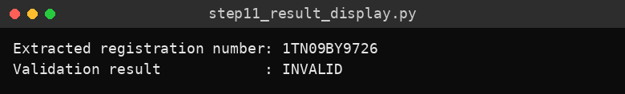
Console output
Figure 1: Original image, cropped plate, extracted number and validation result

Result
The original image, the cropped plate, the extracted text “1TN09BY9726” and the validation result (INVALID, because of the extra leading character) were displayed.

Task 12: Error Handling (Complete Program)

Aim
To show clear error messages when the image or the plate cannot be used, and to let the user check another image again.

Algorithm
- Start and build the knowledge base and all processing functions.
- Ask for an image path; if the user enters q, stop.
- If the file type is not JPG, JPEG or PNG, display an error message.
- If the image cannot be read, display an error message.
- If the plate cannot be detected, display an error message and show a “Plate not found” result.
- If OCR text fails validation, display the raw text, the failed rules and a request to try a clearer picture.
- If the text is valid, display the registration number and the messages.
- Ask for the next image path so that another image can be checked; repeat.
- Stop.

Code
"""
Step 12 - Error Handling + complete program: shows clear error messages and
lets the user check another image again.

Install:
pip install opencv-python pytesseract matplotlib numpy
Also install the Tesseract OCR engine itself:
Windows : https://github.com/UB-Mannheim/tesseract/wiki (then set TESSERACT_PATH below)
Linux : sudo apt install tesseract-ocr
macOS : brew install tesseract

Run:
python step12_error_handling.py car.jpg
(or run without arguments and type the image path when asked)
"""
import re
import sys

import cv2
import matplotlib.pyplot as plt
import numpy as np
import pytesseract

# Windows users: uncomment and fix this path if Tesseract is not on PATH
# TESSERACT_PATH = r"C:\Program Files\Tesseract-OCR\tesseract.exe"
# pytesseract.pytesseract.tesseract_cmd = TESSERACT_PATH

# --------------------------------------------------------------------------
# KNOWLEDGE BASE (Indian vehicle registration format, e.g. TN09AB1234)
# --------------------------------------------------------------------------
KNOWLEDGE_BASE = {
"format_description": "SS DD LLL NNNN (State code, District number, Series letters, 4-digit number)",
"pattern": re.compile(r"^[A-Z]{2}[0-9]{2}[A-Z]{1,3}[0-9]{4}$"),
"state_codes": {
"AN", "AP", "AR", "AS", "BR", "CH", "CG", "DD", "DL", "DN", "GA", "GJ",
"HP", "HR", "JH", "JK", "KA", "KL", "LA", "LD", "MH", "ML", "MN", "MP",
"MZ", "NL", "OD", "OR", "PB", "PY", "RJ", "SK", "TN", "TR", "TS", "UK",
"UP", "WB",
},
# Characters OCR commonly confuses
"to_digit": {"O": "0", "Q": "0", "D": "0", "I": "1", "L": "1", "Z": "2",
"S": "5", "B": "8", "G": "6", "T": "7"},
"to_letter": {"0": "O", "1": "I", "2": "Z", "5": "S", "8": "B", "6": "G"},
}

# --------------------------------------------------------------------------
# 1. NUMBER PLATE DETECTION
# --------------------------------------------------------------------------
def detect_plate_haar(img):
"""Detect plate using OpenCV's pretrained Haar cascade."""
cascade_path = cv2.data.haarcascades + "haarcascade_russian_plate_number.xml"
cascade = cv2.CascadeClassifier(cascade_path)
gray = cv2.cvtColor(img, cv2.COLOR_BGR2GRAY)
plates = cascade.detectMultiScale(gray, scaleFactor=1.1, minNeighbors=4, minSize=(60, 20))
if len(plates) == 0:
return None
x, y, w, h = max(plates, key=lambda p: p[2] * p[3]) # largest detection
return x, y, w, h

def detect_plate_contour(img):
"""Fallback: look for a rectangular contour with a plate-like aspect ratio."""
gray = cv2.cvtColor(img, cv2.COLOR_BGR2GRAY)
gray = cv2.bilateralFilter(gray, 11, 17, 17)
edges = cv2.Canny(gray, 30, 200)
contours, _ = cv2.findContours(edges, cv2.RETR_TREE, cv2.CHAIN_APPROX_SIMPLE)
contours = sorted(contours, key=cv2.contourArea, reverse=True)[:30]

img_area = img.shape[0] * img.shape[1]
for c in contours:
peri = cv2.arcLength(c, True)
approx = cv2.approxPolyDP(c, 0.018 * peri, True)
if len(approx) == 4:
x, y, w, h = cv2.boundingRect(approx)
aspect = w / float(h)
area_ratio = (w * h) / img_area
if 2.0 <= aspect <= 6.5 and 0.005 <= area_ratio <= 0.5:
return x, y, w, h
return None

def detect_plate(img):
box = detect_plate_haar(img)
if box is None:
box = detect_plate_contour(img)
if box is None:
return None, None
x, y, w, h = box
pad = 4
x0, y0 = max(x - pad, 0), max(y - pad, 0)
x1, y1 = min(x + w + pad, img.shape[1]), min(y + h + pad, img.shape[0])
return img[y0:y1, x0:x1], (x0, y0, x1 - x0, y1 - y0)

# --------------------------------------------------------------------------
# 2. PREPROCESSING
# --------------------------------------------------------------------------
def preprocess_plate(plate):
"""Return a list of preprocessed versions of the plate for OCR."""
h, w = plate.shape[:2]
scale = max(1.0, 300.0 / h) # enlarge small plates
plate = cv2.resize(plate, None, fx=scale, fy=scale, interpolation=cv2.INTER_CUBIC)

gray = cv2.cvtColor(plate, cv2.COLOR_BGR2GRAY) # grayscale
blur = cv2.bilateralFilter(gray, 9, 75, 75) # noise reduction
clahe = cv2.createCLAHE(clipLimit=2.0, tileGridSize=(8, 8))
contrast = clahe.apply(blur) # contrast enhancement

_, otsu = cv2.threshold(contrast, 0, 255, cv2.THRESH_BINARY + cv2.THRESH_OTSU)
adaptive = cv2.adaptiveThreshold(contrast, 255, cv2.ADAPTIVE_THRESH_GAUSSIAN_C,
cv2.THRESH_BINARY, 31, 10)

# Add a white border so characters do not touch the image edge
otsu = cv2.copyMakeBorder(otsu, 15, 15, 15, 15, cv2.BORDER_CONSTANT, value=255)
adaptive = cv2.copyMakeBorder(adaptive, 15, 15, 15, 15, cv2.BORDER_CONSTANT, value=255)
return [otsu, adaptive, contrast]

# --------------------------------------------------------------------------
# 3. OCR
# --------------------------------------------------------------------------
def run_ocr(image):
"""Run Tesseract with a few page-segmentation modes; return cleaned candidates."""
whitelist = "ABCDEFGHIJKLMNOPQRSTUVWXYZ0123456789"
candidates = []
for psm in (7, 8, 13):
config = f"--oem 3 --psm {psm} -c tessedit_char_whitelist={whitelist}"
text = pytesseract.image_to_string(image, config=config)
cleaned = re.sub(r"[^A-Z0-9]", "", text.upper())
if cleaned:
candidates.append(cleaned)
return candidates

# --------------------------------------------------------------------------
# 4. EXPERT SYSTEM: RULE-BASED VALIDATION
# --------------------------------------------------------------------------
def apply_ocr_corrections(text):
"""
Rule: the plate layout is L L D D L(1-3) D D D D.
Using the position of each character, replace look-alike characters
(e.g. 'O' where a digit is expected -> '0').
"""
n = len(text)
if not 9 <= n <= 11:
return text, []
series_len = n - 8
layout = ["L", "L", "D", "D"] + ["L"] * series_len + ["D"] * 4

fixed, changes = [], []
for i, (ch, expected) in enumerate(zip(text, layout)):
new = ch
if expected == "D" and ch.isalpha():
new = KNOWLEDGE_BASE["to_digit"].get(ch, ch)
elif expected == "L" and ch.isdigit():
new = KNOWLEDGE_BASE["to_letter"].get(ch, ch)
if new != ch:
changes.append(f"position {i + 1}: '{ch}' -> '{new}'")
fixed.append(new)
return "".join(fixed), changes

def validate_plate(text):
"""Return (is_valid, final_text, messages)."""
messages = []
if not text:
return False, "", ["Rule 1 failed: no characters were read"]

if not 9 <= len(text) <= 11:
return False, text, [f"Rule 2 failed: length {len(text)} is not between 9 and 11"]

corrected, changes = apply_ocr_corrections(text)
if changes:
messages.append("OCR correction applied: " + "; ".join(changes))

if not KNOWLEDGE_BASE["pattern"].match(corrected):
messages.append("Rule 3 failed: text does not match format SS DD LLL NNNN")
return False, corrected, messages

if corrected[:2] not in KNOWLEDGE_BASE["state_codes"]:
messages.append(f"Rule 4 failed: '{corrected[:2]}' is not a valid state/UT code")
return False, corrected, messages

messages.append("All rules satisfied")
return True, corrected, messages

# --------------------------------------------------------------------------
# 5. MAIN PIPELINE
# --------------------------------------------------------------------------
def process_image(path):
if not path.lower().endswith((".jpg", ".jpeg", ".png")):
print("Error: only JPG, JPEG or PNG images are supported.")
return
img = cv2.imread(path)
if img is None:
print(f"Error: could not read image '{path}'. Check the file path.")
return

plate, box = detect_plate(img)
if plate is None:
print("Error: number plate could not be detected. Try a clearer, closer image.")
show_results(img, None, None, "NOT DETECTED", "Plate not found")
return

best_text, best_msgs, valid = "", [], False
first_candidate = ""
for version in preprocess_plate(plate):
for candidate in run_ocr(version):
if not first_candidate:
first_candidate = candidate
ok, final, msgs = validate_plate(candidate)
if ok:
best_text, best_msgs, valid = final, msgs, True
break
if valid:
break

if valid:
print(f"\nExtracted registration number : {best_text}")
print("Validation result : VALID")
for m in best_msgs:
print(" -", m)
show_results(img, box, plate, best_text, "VALID")
else:
print(f"\nOCR text (raw) : {first_candidate or '(nothing read)'}")
print("Validation result : INVALID / not confident")
_, _, msgs = validate_plate(first_candidate)
for m in msgs:
print(" -", m)
print("Please check the image and try again with a clearer picture.")
show_results(img, box, plate, first_candidate or "UNREADABLE", "INVALID")

def show_results(img, box, plate, text, status):
vis = img.copy()
if box is not None:
x, y, w, h = box
cv2.rectangle(vis, (x, y), (x + w, y + h), (0, 255, 0), 3)

fig, axes = plt.subplots(1, 2, figsize=(11, 4.5))
axes[0].imshow(cv2.cvtColor(vis, cv2.COLOR_BGR2RGB))
axes[0].set_title("Original image")
axes[0].axis("off")

if plate is not None:
axes[1].imshow(cv2.cvtColor(plate, cv2.COLOR_BGR2RGB))
else:
axes[1].imshow(np.ones((50, 200, 3), dtype=np.uint8) * 230)
axes[1].set_title(f"Cropped plate\nNumber: {text} Result: {status}")
axes[1].axis("off")
plt.tight_layout()
plt.show()

def main():
path = sys.argv[1] if len(sys.argv) > 1 else None
while True:
if path is None:
path = input("\nEnter car image path (or 'q' to quit): ").strip().strip('"')
if path.lower() == "q":
break
process_image(path)
path = None # ask again so the user can check another image

if __name__ == "__main__":
main()

Output
Text output
Enter car image path (or 'q' to quit): Q4_image.jpeg

OCR text (raw) : 1TN09BY9726
Validation result : INVALID / not confident
- OCR correction applied: position 1: '1' -> 'I'
- Rule 3 failed: text does not match format SS DD LLL NNNN
Please check the image and try again with a clearer picture.

Enter car image path (or 'q' to quit): car.bmp
Error: only JPG, JPEG or PNG images are supported.

Enter car image path (or 'q' to quit): missing.jpg
Error: could not read image 'missing.jpg'. Check the file path.

Enter car image path (or 'q' to quit): no_plate.jpg
Error: number plate could not be detected. Try a clearer, closer image.

Enter car image path (or 'q' to quit): q

Test inputs: Q4_image.jpeg (car image), car.bmp (unsupported file type), missing.jpg (file that does not exist) and no_plate.jpg (a plain grey image created only to show the “plate not detected” error).

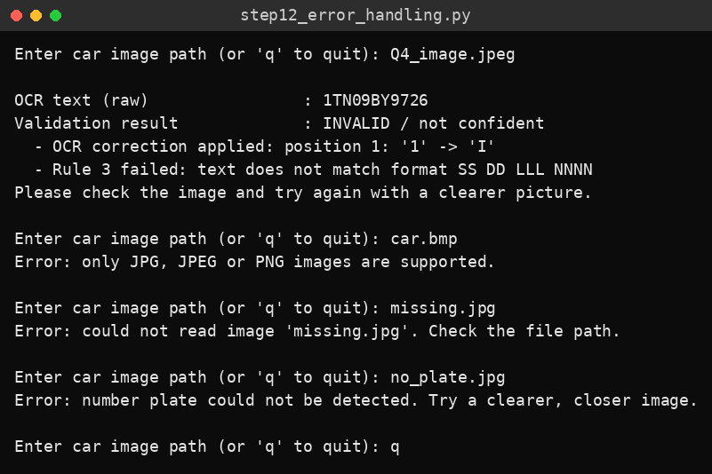
Console output
Figure 1: Result for Q4_image.jpeg
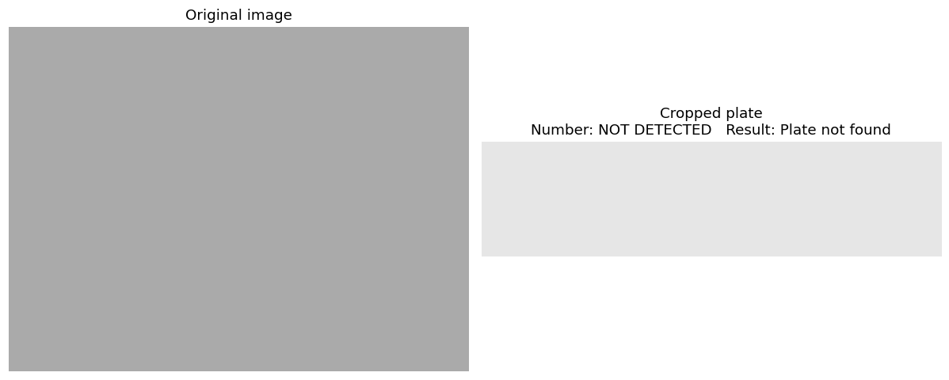
Figure 2: Result for no_plate.jpg

Result
Each error case produced a clear message – unsupported file type, unreadable file, plate not detected and failed validation – and the program asked for another image path after each one.

